Syeda Reeha Quasar

14114802719

4C7

Aim

To create a function power to raise a number m to a power n. The function takes double value for m and integer value for n. Use default value for n to make the function. Calculate the squares when this argument is omitted.

Experiment - 7

Object Oriented Programming Lab

# **EXPERIMENT – 7**

## **Aim:**

To create a function power to raise a number m to a power n. The function takes double value for m and integer value for n. Use default value for n to make the function. Calculate the squares when this argument is omitted.

## **Source Code:**

#include <iostream>

using namespace std;

float power(double base, int powr = 0){

    if (powr == 0) {

        return base * base;

    }

    float res = 1;

    for (int i = 0; i < powr; ++i) {

        res *= base;

    }

    return res;

}

int main(){

    int powr;

    double base;

    cout << "Enter the number whose power you want to calculate:- " << endl;

    cin >> base;

    cout << "Enter the power of the base:- " << endl;

    cin >> powr;

    cout << "The result of " << base << " to the power " << powr << " is " << power(base, powr) << endl;

    return 0;

}

## **Output:**

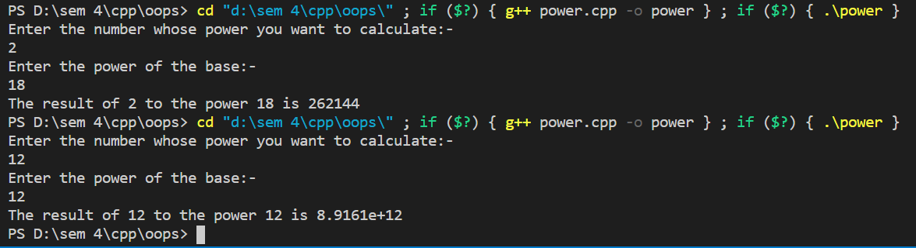

# **Viva Questions**

### 1. What is an abstract class and when do you use it?

Ans.

A class is called an abstract class whose objects can never be created. Such a class exists as a parent for the derived classes. We can make a class abstract by placing a pure virtual function in the class.

### 2. What are destructors in C++?

Ans.

A constructor is automatically called when an object is first created. Similarly when an object is destroyed a function called destructor automatically gets called. A destructor has the same name as the constructor (which is the same as the class name) but is preceded by a tilde.